About this capture
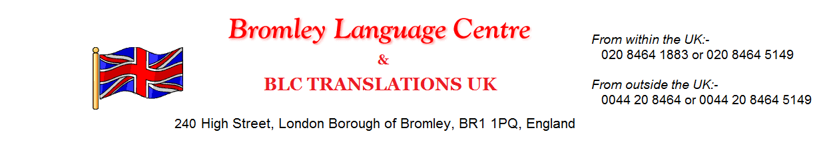
Bromley Language Centre
Bromley Language Centre provides high quality courses in English and foreign languages at very competitive prices in comfortable surroundings in London.
Class sizes are regulated carefully to encourage a good atmosphere and individual participation.
All teachers are highly qualified. Most are university graduates with specialist qualifications in English. They take a personal interest in each student’s development.
Our language centre provides English language courses at every level. So there will always be a course that suits you. All courses are held at our school which is situated in the heart of the London Borough of Bromley, Kent, England.
We are only 15 minutes by train from central London. There are two railway stations. Bromley North will take you to London Bridge and Bromley South will take you to Victoria.
Bromley really is an excellent location. We can arrange accommodation for you should you require it.

BLC TRANSLATIONS UK
London Office: 0208 464 1883 or 0208 464 5149
240 High Street, London Borough of Bromley,
BR1 1PQ
www.bromleylanguage.co.uk
email: bromlang24@aol.com bromlang24@aol.com

Experts in:
French, German, Spanish, Italian, Chinese, Arabic, Russian, Portuguese

Any Major Language…………… Covering all UK
*Free Quotations and advice
*Confidentiality
*Competitive Rates
*20 Years Experience
Here is a selection of customers we have had the pleasure of dealing with:-

Foreign and English Language Courses available in Bromley, Greater London.

